Министерство образования Республики Беларусь

Белорусский Национальный Технический Университет

Факультет информационных технологий и робототехники

Кафедра «Программное обеспечение информационных

систем и технологий»

**Отчёт**

по лабораторной работе № 11

по дисциплине ***«Языки программирования»***

тема: **«Разработка игры с графическим интерфейсом»**

|  |  |  |
| --- | --- | --- |
| Исполнитель: |  | студент группы 10701118  Дубоделов Александр Витальевич |
| Преподаватель: |  | Лапанович И.О |

Минск 2019

Лабораторная работа № 11

**«Разработка игры с графическим интерфейсом»**

**Цель работы:** *приобрести навыки работы с графическим интерфейсом на Python и закрепить их на примере разработки интерактивной игры с графическим интерфейсом с помощью библиотеки PyGame .*

**Основное задание**

Разработать программу(игру) посредством библиотеки PyGame. Реализовать её логику и наглядность реализации.

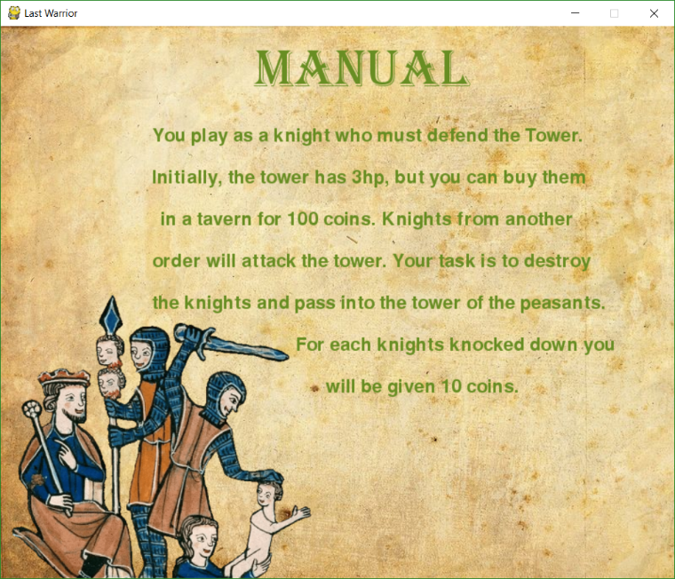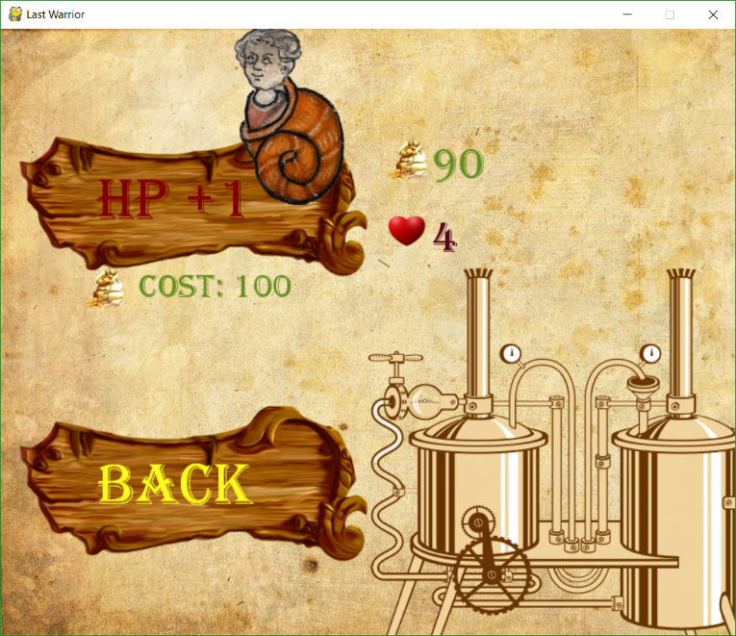**Результаты выполнения основного задания:**

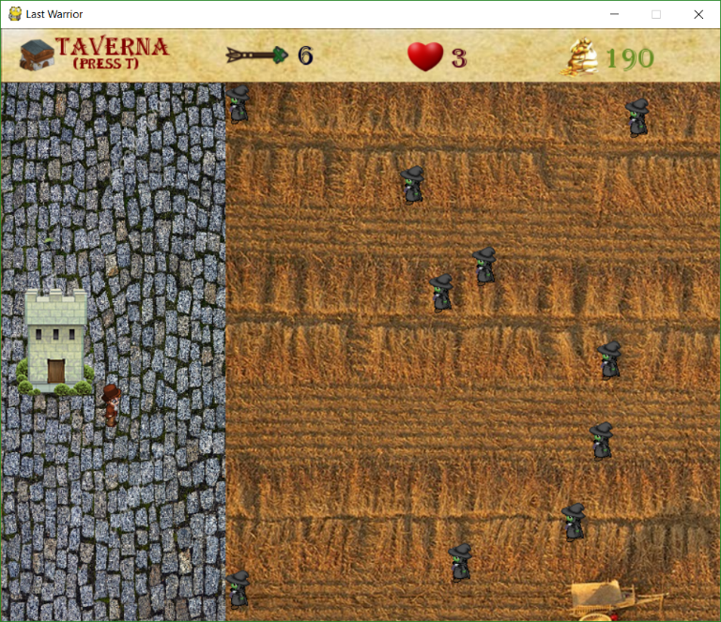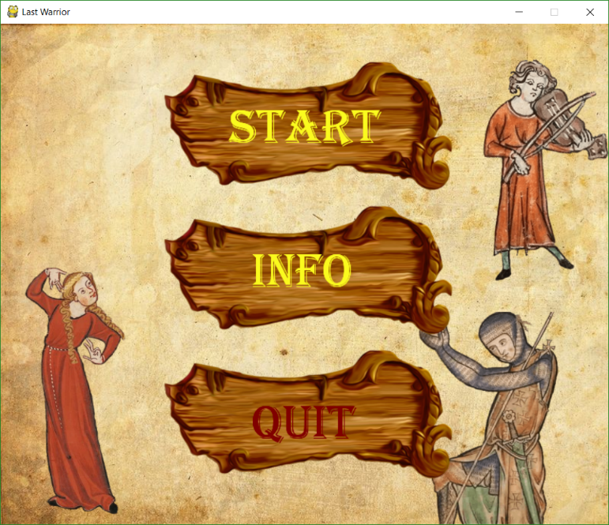

**Листинг основных программ:**

Файл MAIN.py

**from** pygame **import *  
from** menu **import *  
from** tavern **import *  
from** class_list **import *  
from** iintersect **import *  
from** death **import *  
from** random **import** randrange  
  
init**()  
  
  
class Animation(**object**):  
  
 def __init__(**self, sprites_r**=None**, sprites_u**=None**, sprites_d**=None**, timer**=**100**):** self.sprites_r **=** sprites_r  
 self.sprites_u **=** sprites_u  
 self.sprites_d **=** sprites_d  
 self.time **=** timer  
 self.work_time **=** 0  
 self.skip_frame **=** 0  
 self.frame **=** 0  
  
 **def update_r(**self, dt**):** self.work_time **+=** dt  
 self.skip_frame **=** self.work_time **//** self.time  
 **if** self.skip_frame **>** 0**:** self.work_time **=** self.work_time **%** self.time  
 self.frame **+=** self.skip_frame  
 **if** self.frame **>=** len**(**self.sprites_r**):** self.frame **=** 0  
  
 **def update_u(**self, dt**):** self.work_time **+=** dt  
 self.skip_frame **=** self.work_time **//** self.time  
 **if** self.skip_frame **>** 0**:** self.work_time **=** self.work_time **%** self.time  
 self.frame **+=** self.skip_frame  
 **if** self.frame **>=** len**(**self.sprites_u**):** self.frame **=** 0  
  
 **def update_d(**self, dt**):** self.work_time **+=** dt  
 self.skip_frame **=** self.work_time **//** self.time  
 **if** self.skip_frame **>** 0**:** self.work_time **=** self.work_time **%** self.time  
 self.frame **+=** self.skip_frame  
 **if** self.frame **>=** len**(**self.sprites_u**):** self.frame **=** 0  
  
 **def static(**self**):  
 return** self.sprites_r**[**0**]  
  
 def get_sprite_r(**self**):  
 return** self.sprites_r**[**self.frame**]  
  
 def get_sprite_d(**self**):  
 return** self.sprites_d**[**self.frame**]  
  
 def get_sprite_u(**self**):  
 return** self.sprites_u**[**self.frame**]  
  
  
class Zomb(**object**):  
  
 def __init__(**self, x_zomb, y_zomb, sprites_r**=None**, timer**=**100**):** self.sprites_r **=** sprites_r  
 self.time **=** timer  
 self.work_time **=** 0  
 self.skip_frame **=** 0  
 self.frame **=** 0  
 self.check **= False** self.x_zomb **=** x_zomb  
 self.y_zomb **=** y_zomb  
  
 **def update_r(**self, dt**):** self.work_time **+=** dt  
 self.skip_frame **=** self.work_time **//** self.time  
 **if** self.skip_frame **>** 0**:** self.work_time **=** self.work_time **%** self.time  
 self.frame **+=** self.skip_frame  
 **if** self.frame **>=** len**(**self.sprites_r**):** self.frame **=** 0  
  
 **def get_sprite_r(**self**):  
 return** self.sprites_r**[**self.frame**]  
  
 def static(**self**):  
 return** self.sprites_r**[**0**]  
  
  
"""Константы"""**START_POINT **=** 0  
  
ARROW_ST_X **=** 250  
ARROW_ST_Y **=** 20  
  
X_TOWER **= -**5  
Y_TOWER **=** 230  
  
X_TAVERN **=** 20  
Y_TAVERN **=** 10  
  
LENGTH_SCREEN_TOWN **=** 250  
WIDTH_SCREEN_TOWN **=** 600  
  
LENGTH_SCREEN_FIELD **=** 550  
WIDTH_SCREEN_FIELD **=** 600  
  
LENGTH_WINDOW **=** 800  
WIDTH_WINDOW **=** 660  
  
LENGTH_INFO **=** 800  
WIDTH_INFO **=** 60  
  
**"""Звуки"""**mixer.pre_init**(**44100, **-**16, 1, 512**)**mixer.init**()**music_battle **= "battle.ogg"**sound_hit **= "hit.ogg"**track_battle **=** mixer.Sound**(**music_battle**)**track_hit **=** mixer.Sound**(**sound_hit**)  
  
"""Текстуры"""**bg_arrow_static **=** image.load**("Arrow1.png")**bg_grass **=** image.load**("bg_grass2.png")**bg_pergament **=** image.load**("bg_pergament.png")**bg_town **=** image.load**("bg_town.png")**tower **=** image.load**("tower.png")**gold **=** image.load**("gold.png")**heart **=** image.load**("heart.png")**bg_win **=** image.load**("bg_win.png")**bg_tavern **=** image.load**("bg_tavern.png")**bg_died **=** image.load**("bg_died.png")**backgrownd **=** image.load**("Back.png")**bg_arrow **= "Arrow2.png"  
  
"""Создание игроовой поеверхности"""**window **=** display.set_mode**((**LENGTH_WINDOW, WIDTH_WINDOW**))**display.set_caption**("Last Warrior")**town **=** Surface**((**LENGTH_SCREEN_TOWN, WIDTH_SCREEN_TOWN**))**field **=** Surface**((**LENGTH_SCREEN_FIELD, WIDTH_SCREEN_FIELD**))**info_string **=** Surface**((**LENGTH_INFO, WIDTH_INFO**))  
  
"""Создание меню"""**positions **= [(**300, 100, **u"Start"**, **(**250, 250, 30**)**, **(**128, 0, 0**)**, 0**)**,  
 **(**330, 290, **u"Info"**, **(**250, 250, 30**)**, **(**128, 0, 0**)**, 1**)**,  
 **(**330, 490, **u"Quit"**, **(**250, 250, 30**)**, **(**128, 0, 0**)**, 2**)]**menu **=** Menu**(**positions**)**menu.start_menu**(**window, bg_win**)  
  
"""Создание таверны"""**tavern_option **= [(**105, 150, **u"HP +1"**, **(**250, 250, 30**)**, **(**128, 0, 0**)**, 0**)**,  
 **(**105, 460, **u"Back"**, **(**250, 250, 30**)**, **(**128, 0, 0**)**, 1**)]**tavern_menu **=** Tavern**(**tavern_option**)  
  
"""Задание текстур персоонажа"""**sprite_z **=** image.load**("zomb.png")**.convert_alpha**()**sprite_h_r **=** image.load**("hero.png")**.convert_alpha**()**sprite_h_u **=** image.load**("hero_u.png")**.convert_alpha**()**sprite_h_d **=** image.load**("hero_d.png")**.convert_alpha**()  
  
"""Создание текстовых переменных"""**font.init**()**health **=** font.SysFont**("Algerian"**, 32**)**coins **=** font.SysFont**("Algerian"**, 32**)**tavern **=** font.SysFont**("Algerian"**, 28**)**tavern_f **=** font.SysFont**("Algerian"**, 16**)**arrow **=** font.SysFont**("Algerian"**, 32**)**press_e **=** font.SysFont**("Algerian"**, 32**)  
  
"""Создание стерл, выпускаемых героем"""**x_arrow **= -**100  
y_arrow **=** 0  
arr **=** Object**(**x_arrow, ARROW_ST_Y, bg_arrow**)**arr1 **=** Object**(**x_arrow, ARROW_ST_Y, bg_arrow**)**arr2 **=** Object**(**x_arrow, ARROW_ST_Y, bg_arrow**)**arr3 **=** Object**(**x_arrow, ARROW_ST_Y, bg_arrow**)**counter_tower **=** 15  
counter_hero **=** 0  
  
**"""Создание зомби"""**anim_z **= []**anim_z.append**(**sprite_z.subsurface**((**0, 0, 31, 48**)))**anim_z.append**(**sprite_z.subsurface**((**31, 0, 31, 48**)))**anim_z.append**(**sprite_z.subsurface**((**62, 0, 31, 48**)))**anim_z.append**(**sprite_z.subsurface**(**95, 0, 31, 48**))**x_zomb **=** 860  
y_zomb **= None**timer_z **=** 180  
AMOUNT_OF_ZOMB **=** 15  
zombs **= []**zomb **= None**speed **=** 0  
zomb_on_the_field **=** 0  
  
**for** i **in** range**(**10**):** x_zomb **=** 860  
 y_zomb **=** 60  
 zombarik **=** Zomb**(**x_zomb, y_zomb **+** i **\*** 60, anim_z, timer_z**)** zombs.append**(**zombarik**)  
  
"""Создание анимированного ГЕРОЯ"""**anim_h_r **= []**anim_h_r.append**(**sprite_h_r.subsurface**((**0, 0, 33, 48**)))**anim_h_r.append**(**sprite_h_r.subsurface**((**33, 0, 33, 48**)))**anim_h_r.append**(**sprite_h_r.subsurface**((**66, 0, 33, 48**)))**anim_h_r.append**(**sprite_h_r.subsurface**(**99, 0, 29, 48**))**anim_h_u **= []**anim_h_u.append**(**sprite_h_u.subsurface**((**0, 0, 33, 48**)))**anim_h_u.append**(**sprite_h_u.subsurface**((**33, 0, 33, 48**)))**anim_h_u.append**(**sprite_h_u.subsurface**((**66, 0, 33, 48**)))**anim_h_u.append**(**sprite_h_u.subsurface**(**99, 0, 29, 48**))**anim_h_d **= []**anim_h_d.append**(**sprite_h_d.subsurface**((**0, 0, 33, 48**)))**anim_h_d.append**(**sprite_h_d.subsurface**((**33, 0, 33, 48**)))**anim_h_d.append**(**sprite_h_d.subsurface**((**66, 0, 33, 48**)))**anim_h_d.append**(**sprite_h_d.subsurface**(**99, 0, 29, 48**))**speed_of_hero **=** 1  
x_hero **=** 50  
y_hero **=** 300  
hero_flag **= True**timer **=** 180  
hero **=** Animation**(**anim_h_r, anim_h_u, anim_h_d, timer**)  
  
"""Задание переменных отвечающих за жизни и деньги"""**amount_of_health **=** 3  
amount_of_coins **=** 100  
  
#"""Создание анимированного КОЛХОЗНИКА"""  
#sprite_k = image.load("krest.png").convert_alpha()  
#anim_k = []  
  
**"""Таймер"""**clock **=** time.Clock**()**dt **=** 0  
  
**"""Cмерть"""**die **=** Died**()  
  
"""Скорость отклика"""**key.set_repeat**(**100, 1**)  
  
"""Запуск игры"""**flag **= True  
while** flag**:** track_battle.play**(-**1**)  
  
 """Закраска игровых полей Город, Поле, Информационная строка"""** town.fill**((**100, 100, 100**))** field.fill**((**50, 70, 100**))** info_string.fill**((**170, 170, 170**))  
  
 """Вывод на экран полей Город, Поле, Информационная строка"""** field.blit**(**bg_grass, **(**START_POINT, START_POINT**))** info_string.blit**(**bg_pergament, **(**START_POINT, START_POINT**))** info_string.blit**(**bg_tavern, **(**X_TAVERN, Y_TAVERN**))** info_string.blit**(**bg_arrow_static, **(**ARROW_ST_X, ARROW_ST_Y**))** info_string.blit**(**gold, **(**620, 10**))** info_string.blit**(**heart, **(**450, 12**))** info_string.blit**(**arrow.render**(**str**(**counter_hero**)**, 1, **(**0, 0, 35**))**, **(**330, 12**))** info_string.blit**(**coins.render**(**str**(**amount_of_coins**)**, 1, **(**104, 142, 35**))**, **(**670, 15**))** info_string.blit**(**health.render**(**str**(**amount_of_health**)**, 1, **(**86, 3, 25**))**, **(**500, 15**))** info_string.blit**(**tavern.render**(u"Taverna"**, 1, **(**128, 0, 0**))**, **(**60, 5**))** info_string.blit**(**tavern_f.render**(u"(press T)"**, 1, **(**128, 0, 0**))**, **(**80, 30**))** town.blit**(**bg_town, **(**START_POINT, START_POINT**))** town.blit**(**tower, **(**X_TOWER, Y_TOWER**))  
 if** intersect**(**60, x_hero, 294, y_hero, 30, 30**):** town.blit**(**press_e.render**(u"E"**, 1, **(**0, 0, 35**))**, **(**X_TOWER **+** 55, Y_TOWER **+** 5**))** ######  
 **"""Обработка событий"""  
 for** i **in** event.get**():  
 if** i.type **==** QUIT**:** flag **= False  
 if** i.type **==** KEYDOWN**:  
 if** i.key **==** K_e**:** key.set_repeat**(**250, 1**)  
 if** intersect**(**60, x_hero, 294, y_hero, 30, 30**):  
 if** counter_hero **<** counter_tower**:** counter_hero **=** 0  
 counter_hero **+=** counter_tower  
 **if** i.key **==** K_LEFT **or** i.key **==** K_a**:  
 if** x_hero **>** START_POINT**:** hero_flag **= False** x_hero **-=** speed_of_hero  
 hero.update_r**(**dt**)** town.blit**(**hero.get_sprite_r**()**, **(**x_hero, y_hero**))  
 if** i.key **==** K_RIGHT **or** i.key **==** K_d**:  
 if** x_hero **<** LENGTH_SCREEN_TOWN **-** 33**:** hero_flag **= False** x_hero **+=** speed_of_hero  
 hero.update_r**(**dt**)** town.blit**(**hero.get_sprite_r**()**, **(**x_hero, y_hero**))  
 if** i.key **==** K_UP **or** i.key **==** K_w**:  
 if** y_hero **>** START_POINT**:** hero_flag **= False** y_hero **-=** speed_of_hero  
 hero.update_u**(**dt**)** town.blit**(**hero.get_sprite_u**()**, **(**x_hero, y_hero**))  
 if** i.key **==** K_DOWN **or** i.key **==** K_s**:  
 if** y_hero **<** WIDTH_SCREEN_TOWN **-** 48**:** hero_flag **= False** y_hero **+=** speed_of_hero  
 hero.update_d**(**dt**)** town.blit**(**hero.get_sprite_d**()**, **(**x_hero, y_hero**))  
 if** i.key **==** K_ESCAPE**:** track_battle.stop**()** menu.start_menu**(**window, bg_win**)** key.set_repeat**(**100, 1**)  
 if** i.key **==** K_t**:** amount_of_health, amount_of_coins **=** tavern_menu.start_tavern**(**window, bg_win, amount_of_coins,  
 amount_of_health**)** key.set_repeat**(**100, 1**)  
 if** i.key **==** K_SPACE**:** track_hit.play**()  
 if** counter_hero **>** 0**:  
 if not** arr3.push **and** arr2.push**:** arr3.x **=** x_hero **+** 10  
 arr3.y **=** y_hero **+** 60  
 arr3.push **= True** counter_hero **-=** 1  
 **if not** arr2.push **and** arr1.push**:** arr2.x **=** x_hero **+** 10  
 arr2.y **=** y_hero **+** 60  
 arr2.push **= True** counter_hero **-=** 1  
 **if not** arr1.push **and** arr.push**:** arr1.x **=** x_hero **+** 10  
 arr1.y **=** y_hero **+** 60  
 arr1.push **= True** counter_hero **-=** 1  
 **if not** arr.push**:** arr.x **=** x_hero **+** 10  
 arr.y **=** y_hero **+** 60  
 arr.push **= True** counter_hero **-=** 1  
  
 **if** arr.x **>** LENGTH_WINDOW**:** arr.push **= False  
  
 if not** arr.push**:** arr.y **=** ARROW_ST_Y  
 arr.x **= -**100  
 **else:** arr.x **+=** 5  
  
 **if** arr1.x **>** LENGTH_WINDOW**:** arr1.push **= False  
  
 if not** arr1.push**:** arr1.y **=** ARROW_ST_Y  
 arr1.x **= -**100  
 **else:** arr1.x **+=** 5  
  
 **if** arr2.x **>** LENGTH_WINDOW**:** arr2.push **= False  
  
 if not** arr2.push**:** arr2.y **=** ARROW_ST_Y  
 arr2.x **= -**100  
 **else:** arr2.x **+=** 5  
  
 **if** arr3.x **>** LENGTH_WINDOW**:** arr3.push **= False  
  
 if not** arr3.push**:** arr3.y **=** ARROW_ST_Y  
 arr3.x **= -**100  
 **else:** arr3.x **+=** 5  
  
 **if** hero_flag**:** town.blit**(**hero.static**()**, **(**x_hero, y_hero**))** hero_flag **= True** window.blit**(**town, **(**START_POINT, WIDTH_INFO**))** window.blit**(**field, **(**LENGTH_SCREEN_TOWN, WIDTH_INFO**))** window.blit**(**info_string, **(**START_POINT, START_POINT**))  
  
 for** g **in** range**(**len**(**zombs**)):** zombs**[**g**]**.check **= True** zombs**[**g**]**.update_r**(**dt**)** window.blit**(**zombs**[**g**]**.get_sprite_r**()**, **(**zombs**[**g**]**.x_zomb, zombs**[**g**]**.y_zomb**))** zomb_on_the_field **+=** 1  
  
 **for** j **in** range**(**len**(**zombs**)):  
  
 if** amount_of_health **<=** 3**:** speed **=** 0.3  
 speed_of_hero **=** 1  
 **if** 3 **<** amount_of_health **<=** 5**:** speed **=** 0.5  
 speed_of_hero **=** 1.2  
 **if** 5 **<** amount_of_health **<=** 10**:** speed **=** 0.7  
 speed_of_hero **=** 1.4  
 **if** amount_of_health **>** 10**:** speed **=** 1.2  
 speed_of_hero **=** 1.7  
  
 **if** zombs**[**j**]**.x_zomb **<** 0**:** zombs**[**j**]**.check **= False** zomb_on_the_field **-=** 1  
 amount_of_health **-=** 1  
  
 **if** intersect**(**zombs**[**j**]**.x_zomb, arr1.x, zombs**[**j**]**.y_zomb **+** 17, arr1.y, 24, 24**):** amount_of_coins **+=** 10  
 zombs**[**j**]**.check **= False** zomb_on_the_field **-=** 1  
 arr1.x **=** 900  
 arr1.y **=** 0  
 **if** intersect**(**zombs**[**j**]**.x_zomb, arr.x, zombs**[**j**]**.y_zomb **+** 17, arr.y, 24, 24**):** amount_of_coins **+=** 10  
 zombs**[**j**]**.check **= False** zomb_on_the_field **-=** 1  
 arr.x **=** 900  
 arr.y **=** 0  
 **if** intersect**(**zombs**[**j**]**.x_zomb, arr2.x, zombs**[**j**]**.y_zomb **+** 17, arr2.y, 24, 24**):** amount_of_coins **+=** 10  
 zombs**[**j**]**.check **= False** zomb_on_the_field **-=** 1  
 arr2.x **=** 900  
 arr2.y **=** 0  
 **if** intersect**(**zombs**[**j**]**.x_zomb, arr3.x, zombs**[**j**]**.y_zomb **+** 17, arr3.y, 24, 24**):** amount_of_coins **+=** 10  
 zombs**[**j**]**.check **= False** zomb_on_the_field **-=** 1  
 arr3.x **=** 900  
 arr3.y **=** 0  
  
 **if not** zombs**[**j**]**.check**:** zombs**[**j**]**.x_zomb **=** x_zomb  
 zombs**[**j**]**.y_zomb **=** randrange**(**60, 600, 15**)  
 else:** zombs**[**j**]**.x_zomb **-=** speed  
  
 **if** amount_of_health **<=** 0**:** track_battle.stop**()** amount_of_health **=** 3  
 amount_of_coins **=** 100  
 counter_hero **=** 0  
 **for** i **in** range**(**10**):** zombs**[**i**]**.x_zomb **=** 860  
 zombs**[**i**]**.y_zomb **=** 60 **+** i **\*** 60  
 die.start_deth**(**window**)** arr.render**(**window**)** arr1.render**(**window**)** arr2.render**(**window**)** arr3.render**(**window**)** display.flip**()** dt **=** clock.tick**(**120**)**

Файл menu.py

**from** pygame **import *  
from** Options **import *  
import** sys  
  
START_POINT **=** 0  
  
  
**class Menu(**object**):  
 def __init__(**self, positions**):** self.positions **=** positions  
  
 **def render(**self, window, font, num_option**):  
 for** i **in** self.positions**:  
 if** num_option **==** i**[**5**]:** window.blit**(**font.render**(**i**[**2**]**, 1, i**[**4**])**, **(**i**[**0**]**, i**[**1**]))  
 else:** window.blit**(**font.render**(**i**[**2**]**, 1, i**[**3**])**, **(**i**[**0**]**, i**[**1**]))  
  
 def start_menu(**self, window, bg_win**):  
 """ЗАпуск меню"""** init**()  
 """Звуки"""** mixer.pre_init**(**44100, **-**16, 1, 512**)** mixer.init**()** music_menu **= "menu.ogg"** track_menu **=** mixer.Sound**(**music_menu**)** track_menu.play**(-**1**)** flag **= True** font_menu **=** font.SysFont**("Algerian,"**, 64**)** option **=** 0  
  
 key.set_repeat**(**1000, 1**)** mouse.set_visible**(True)** bg_menu_1 **=** image.load**("bg_menu_1.png")** bg_menu_2 **=** image.load**("bg_menu_2.png")** bg_menu_3 **=** image.load**("bg_menu_3.png")** bg_box1 **=** image.load**("bg_box1.png")** bg_box2 **=** image.load**("bg_box1.png")** bg_box3 **=** image.load**("bg_box1.png")  
  
 while** flag**:** track_menu.play**(-**1**)** window.blit**(**bg_win, **(**START_POINT, START_POINT**))** window.blit**(**bg_menu_1, **(**630, 10**))** window.blit**(**bg_menu_2, **(-**70, 300**))** window.blit**(**bg_menu_3, **(**510, 380**))** window.blit**(**bg_box1, **(**215, 50**))** window.blit**(**bg_box2, **(**215, 240**))** window.blit**(**bg_box3, **(**215, 430**))** map **=** mouse.get_pos**()  
 for** i **in** self.positions**:  
 if (**map**[**0**] >** i**[**0**] -** 100 **and** map**[**0**] <** i**[**0**] +** 250 **and** map**[**1**] >** i**[**1**] -** 50 **and** map**[**1**] <** i**[**1**] +** 90**):** option **=** i**[**5**]** self.render**(**window, font_menu, option**)  
  
 for** i **in** event.get**():  
 if** i.type **==** QUIT**:** sys.exit**()  
 if** i.type **==** KEYDOWN**:  
 if** i.key **==** K_ESCAPE**:** sys.exit**()  
 if** i.key **==** K_UP **or** i.key **==** K_w**:  
 if** option **>** 0**:** option **-=** 1  
 **if** i.key **==** K_DOWN **or** i.key **==** K_s**:  
 if** option **<** len**(**self.positions**) -** 1**:** option **+=** 1  
 **if** i.key **==** K_RETURN**:  
 if** option **==** 0**:** track_menu.stop**()** flag **= False  
 if** option **==** 1**:** num **=** Options**()** num.start_options**(**window, bg_win**)  
 if** option **==** 2**:** track_menu.stop**()** sys.exit**()  
 if** i.type **==** MOUSEBUTTONDOWN **and** i.button **==** 1**:** track_menu.stop**()  
 if** option **==** 0**:** flag **= False  
 elif** option **==** 1**:** num **=** Options**()** num.start_options**(**window, bg_win**)  
 elif** option **==** 2**:** sys.exit**()** display.flip**()**

Файл death.py

**from** pygame **import *  
import** sys  
  
bg_died **=** image.load**("bg_died.png")**backgrownd **=** image.load**("Back.png")  
  
  
class Died(**object**):  
 def __init__(**self**):** self.back **=** backgrownd  
 self.died **=** bg_died  
  
 **def start_deth(**self, window**):** init**()** mixer.pre_init**(**44100, **-**16, 1, 512**)** mixer.init**()** music_death **= "death.ogg"** mixer.music.set_volume**(**0.5**)** track_death **=** mixer.Sound**(**music_death**)** flag **= True  
 while** flag**:** track_death.play**(-**1**)** window.blit**(**self.back, **(**0, 0**))** window.blit**(**self.died, **(**300, **-**40**))  
 for** i **in** event.get**():  
 if** i.type **==** QUIT**:** sys.exit**()  
 if** i.type **==** KEYDOWN**:  
 if** i.key **==** K_ESCAPE**:** track_death.stop**()  
 return** 0  
 display.flip**()**

Файл tavern.py

**from** pygame **import *  
from** Options **import *  
import** sys  
  
START_POINT **=** 0  
COST **=** 100  
  
  
**class Tavern(**object**):  
 def __init__(**self, positions**):** self.positions **=** positions  
  
 **def render(**self, window, font, num_option**):  
 for** i **in** self.positions**:  
 if** num_option **==** i**[**5**]:** window.blit**(**font.render**(**i**[**2**]**, 1, i**[**4**])**, **(**i**[**0**]**, i**[**1**]))  
 else:** window.blit**(**font.render**(**i**[**2**]**, 1, i**[**3**])**, **(**i**[**0**]**, i**[**1**]))  
  
 def start_tavern(**self, window, bg_win, amount_of_coins, amount_of_health**):  
 """ЗАпуск меню"""** font_menu **=** font.SysFont**("Algerian,"**, 64**)** option **=** 0  
  
 font.init**()** my_health **=** font.SysFont**("Algerian"**, 48**)** my_coins **=** font.SysFont**("Algerian"**, 48**)** cost **=** font.SysFont**("Algerian"**, 36**)** key.set_repeat**(**1000, 1**)** mouse.set_visible**(True)** bg_box1 **=** image.load**("bg_box1.png")** bg_box2 **=** image.load**("bg_box1.png")** gold **=** image.load**("gold.png")** gold_c **=** image.load**("gold.png")** heart **=** image.load**("heart.png")** bg_decor1 **=** image.load**("bg_tavern_decor1.png")** bg_decor2 **=** image.load**("bg_tavern_decor2.png")  
  
 while True:** window.blit**(**bg_win, **(**START_POINT, START_POINT**))** window.blit**(**bg_box1, **(**20, 100**))** window.blit**(**bg_box2, **(**20, 410**))** map **=** mouse.get_pos**()  
 for** i **in** self.positions**:  
 if (**map**[**0**] >** i**[**0**] -** 100 **and** map**[**0**] <** i**[**0**] +** 250 **and** map**[**1**] >** i**[**1**] -** 50 **and** map**[**1**] <** i**[**1**] +** 90**):** option **=** i**[**5**]** self.render**(**window, font_menu, option**)  
  
 for** i **in** event.get**():  
 if** i.type **==** QUIT**:** sys.exit**()  
 if** i.type **==** KEYDOWN**:  
 if** i.key **==** K_ESCAPE**:  
 return** amount_of_health, amount_of_coins  
 **if** i.key **==** K_UP **or** i.key **==** K_w**:  
 if** option **>** 0**:** option **-=** 1  
 **if** i.key **==** K_DOWN **or** i.key **==** K_s**:  
 if** option **<** len**(**self.positions**) -** 1**:** option **+=** 1  
 **if** i.key **==** K_RETURN**:  
 if** option **==** 1**:  
 return** amount_of_health, amount_of_coins  
 **if** option **==** 0**:  
 if** amount_of_coins **>=** COST**:** amount_of_health **+=** 1  
 amount_of_coins **-=** COST  
 **if** i.type **==** MOUSEBUTTONDOWN **and** i.button **==** 1**:  
 if** option **==** 1**:  
 return** amount_of_health, amount_of_coins  
 **elif** option **==** 0**:  
 if** amount_of_coins **>=** COST**:** amount_of_health **+=** 1  
 amount_of_coins **-=** COST  
  
 window.blit**(**bg_decor1, **(**220, 0**))** window.blit**(**bg_decor2, **(**400, 260**))** window.blit**(**gold, **(**420, 120**))** window.blit**(**heart, **(**420, 200**))** window.blit**(**gold_c, **(**90, 260**))** window.blit**(**my_coins.render**(**str**(**amount_of_coins**)**, 1, **(**104, 142, 35**))**, **(**470, 120**))** window.blit**(**my_health.render**(**str**(**amount_of_health**)**, 1, **(**86, 3, 25**))**, **(**470, 200**))** window.blit**(**cost.render**(u"Cost: 100"**, 1, **(**104, 142, 35**))**, **(**150, 260**))** display.flip**()**

Файл Options.py

**from** pygame **import *  
import** sys  
  
  
**class Options(**object**):  
 def __init__(**self**):** print**("")  
  
 def start_options(**self, window, bg_win**):** START_POINT **=** 0  
  
 bg_op **=** image.load**("bg_op.png")** font.init**()** headline **=** font.SysFont**("Algerian"**, 64**)** text1 **=** font.SysFont**("MS PGothic"**, 32**)** text2 **=** font.SysFont**("MS PGothic"**, 32**)** text3 **=** font.SysFont**("MS PGothic"**, 32**)** text4 **=** font.SysFont**("MS PGothic"**, 32**)** text5 **=** font.SysFont**("MS PGothic"**, 32**)** text6 **=** font.SysFont**("MS PGothic"**, 32**)** text7 **=** font.SysFont**("MS PGothic"**, 32**)** flag **= True  
 while** flag**:  
  
 for** i **in** event.get**():  
 if** i.type **==** QUIT**:** sys.exit**()  
 if** i.type **==** KEYDOWN**:  
 if** i.key **==** K_ESCAPE**:** flag **= False** window.blit**(**bg_win, **(**START_POINT, START_POINT**))** window.blit**(**bg_op, **(**10, 300**))** window.blit**(**headline.render**(u"Manual"**, 1, **(**104, 142, 35**))**, **(**300, 15**))** window.blit**(**text1.render**(u"You play as a knight who must defend the Tower."**, 1, **(**104, 142, 35**))**, **(**180, 120**))** window.blit**(**text2.render**(u"Initially, the tower has 3hp, but you can buy them"**, 1, **(**104, 142, 35**))**,  
 **(**180, 170**))** window.blit**(**text3.render**(u"in a tavern for 100 coins. Knights from another"**, 1, **(**104, 142, 35**))**, **(**190, 220**))** window.blit**(**text4.render**(u"order will attack the tower. Your task is to destroy"**, 1, **(**104, 142, 35**))**,  
 **(**180, 270**))** window.blit**(**text5.render**(u"the knights and pass into the tower of the peasants."**, 1, **(**104, 142, 35**))**,  
 **(**180, 320**))** window.blit**(**text6.render**(u"For each knights knocked down you "**, 1, **(**104, 142, 35**))**,  
 **(**350, 370**))** window.blit**(**text7.render**(u" will be given 10 coins."**, 1, **(**104, 142, 35**))**,  
 **(**380, 420**))** display.flip**()**

Файл class_list.py

**from** pygame **import *  
  
  
class Object(**object**):  
 def __init__(**self, obj_x, obj_y, filename**):** self.x **=** obj_x  
 self.y **=** obj_y  
 self.bitmpap **=** image.load**(**filename**)** self.bitmpap.set_colorkey**((**0, 0, 0**))** self.push **= False  
  
 def render(**self, screen**):** screen.blit**(**self.bitmpap, **(**self.x, self.y**))**

Файл iintersect.py’

**def intersect(**s1_x, s2_x, s1_y, s2_y, width_obj1, length_obj1**):  
 if ((**s1_x **>** s2_x **-** length_obj1**) and (**s1_x **<** s2_x **+** length_obj1**)  
 and (**s1_y **>** s2_y **-** width_obj1**) and (**s1_y **<** s2_y **+** width_obj1**)):  
 return True  
 else:  
 return False**